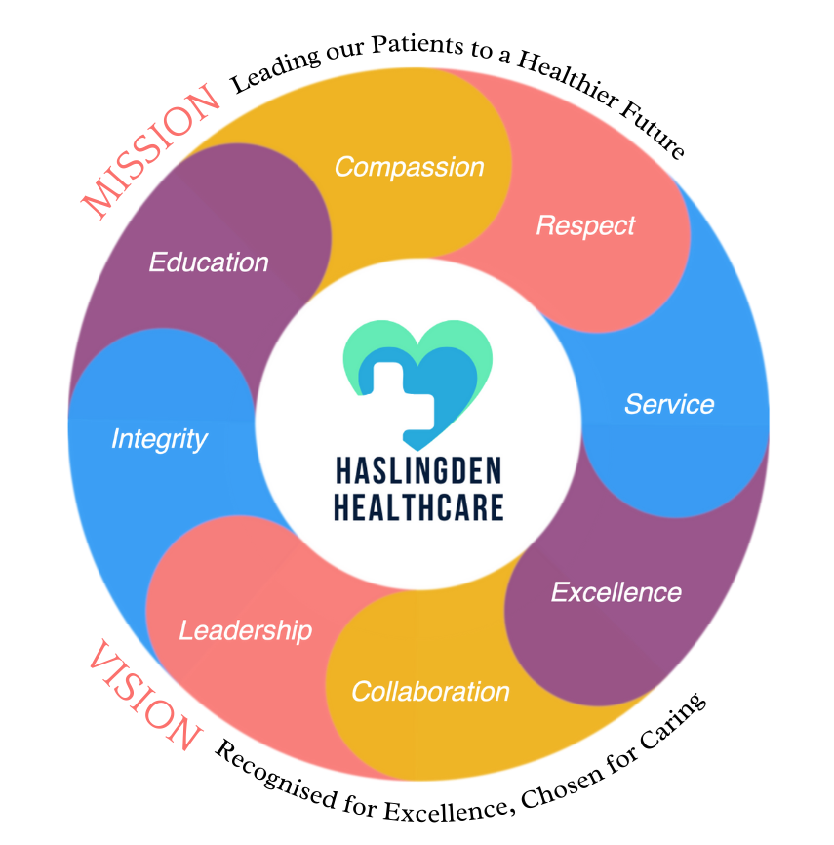

***in this issue MARCH 2025 >>>***

Issue

**Every March the brain tumour awareness team lead the way with a packed programme of activities to raise vital awareness and funds to get closer to our vision of finding a cure for all types of brain tumours.**

**This year, they celebrate their 15th anniversary, there are many ways you can get involved during Brain Tumour Awareness Month to bring hope to the one in three people who knows someone affected by this devastating disease.**

***International Women’s Day – 8th March 2025***

**International Women's Day (IWD) has been around for over a hundred years, as have many of the issues still impacting women's advancement. Since 1911, IWD belongs to all who care about women's equality. It celebrates the social, economic, cultural and political achievements of women. Celebrate women's achievement. Raise awareness about discrimination. Take action to forge gender parity. All IWD activity is valid, that's what makes IWD so inclusive.**

***Brain Tumour Awareness Month - March***

**Haslingden Health Care NEWS**

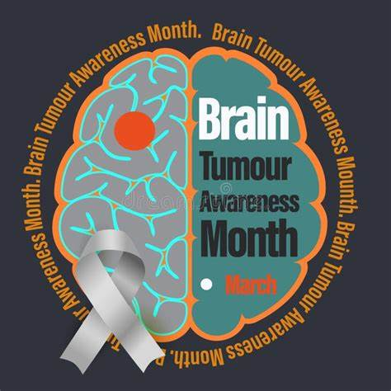

* *Covid spring boosters*
* *Travel Vaccines*
* *MyGP App appointments*
* *Home blood pressure machine deposit required*
* *Clinical Trials*
* *Stress awareness month*
* *Transgender visibility day*
* *New staff*
* *Smoking cessation*

And MORE…

The Enhanced Access Service

The Enhanced Access Service in Rossendale is held at Rossendale Health Centre (Inside Ilex View Practice) as well as Bacup Health Centre (Inside Irwell Medical Practice)

The service is held at Rossendale Health Centre, 17:00pm – 20:45pm on Tuesdays, Wednesdays, Fridays and Saturdays 9-2pm. The service is held at Bacup Health Centre, 17:00pm – 20:45pm on Mondays and Thursdays. Appointments within this service are both Face to Face and Remote (Telephone/Video Call).

These appointments can be with either a GP, ANP, Practice Nurse or Health Care Assistant. These clinicians have access to your GP Practice record, to enable them to see all results, letters and consultations to enable a continuity of care during your appointment with the Enhanced Access Service.

Web: [**https://eastlancashirealliance.co.uk**](https://eastlancashirealliance.co.uk/)

Facebook: [**https://www.facebook.com/EastLancsAlliance/**](https://www.facebook.com/EastLancsAlliance/)

Email: [**Ela.servicefeedback@nhs.net**](mailto:Ela.servicefeedback@nhs.net)

**THE SPRING ISSUE**



**Dr Rajan**

***Hello I am Dr Rashmy Rajan, my qualifications are MBBS,MRCGP,DRCOG,DFFP.***

***I have been a GP for 16yrs and I am based mainly around the Lancashire area. I have been a locum doctor for the last 2 years as I have a small baby and timings are better. I have a special interest in women's health and provide family planning services.***

**Sumayyah and Rebecca**

***Hello, we are the new receptionists at Haslingden Healthcare, and we are more than happy to help you arrange appointments, answer any queries that you may have and care navigate you to the appropriate service that you require.***

***Sumayyah has also completed phlebotomy training and is now running her own blood clinic\*\****

*Staff News!*



Stress Awareness Month – April

**Increasing public awareness about both the causes and cures for our modern stress epidemic. Together we can #LeadWithLove**

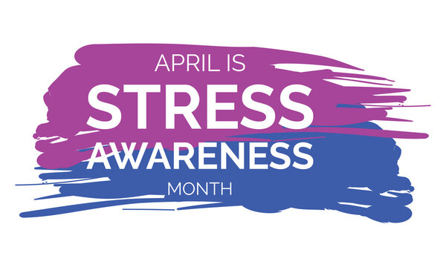

Travel Vaccines

We are now offering NHS travel vaccines at the practice. To find out further information and to see if you are eligible, please contact reception and request a travel vaccine questionnaire form.

A questionnaire will be sent across to you to complete and return to us. A nurse will then review this form and an appointment will be made dependent on the review.

**Please contact the practice at least 12 weeks in advance before your travel date to start this process**

Haslingden Healthcare are now offering a service for all patients to send directly Non-Medical Queries and Admin Requests using the link below, which includes sicknotes, letters and updates regarding test results.

You can access this service using the link below.

[**https://florey.accurx.com/p/P81099**](https://florey.accurx.com/p/P81099)

**You can also access this service using the NHS App.**

**For further information please speak to the reception team.**

A day to celebrate transgender people and raise awareness surrounding the discrimination they face. A day to honor the joy and resilience of trans and non-binary individuals worldwide.

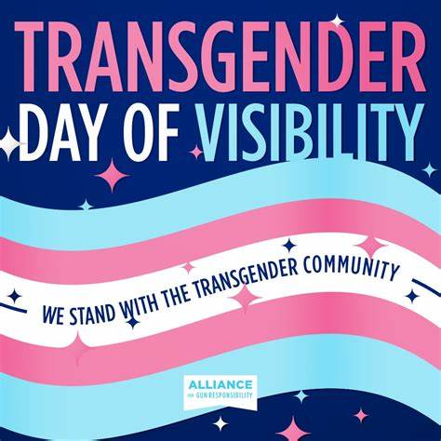

Transgender Day of Visibility – 31st March

*Patient Non Medical Queries -*

***ask the experts >>>***

**Home Blood Pressure Monitoring Deposits**

Our practice has now implemented a new deposit scheme for loaning home blood pressure monitoring machines.

We will now require a £10 deposit before loaning you a machine - this will be returned to you when you bring the machine back to reception.

*Please note if you do not bring the home monitoring machine back to reception within 2 weeks this deposit will be non-refundable.*

**The practice will be closed on the following date:**

* **Good Friday 18th April**
* **Easter Monday 21st April**
* **Early May Bank Holiday 5th May**
* **Spring Bank Holiday 26th May**

**For urgent requests please contact NHS 111. In an emergency dial 999.**

COVID VACCINES

We are now approaching the time for our next batch of covid spring boosters.

These will be offered in April. You will receive an invite for this if you are eligible.

You can get your covid vaccine done at your local chemist or by ringing 119.

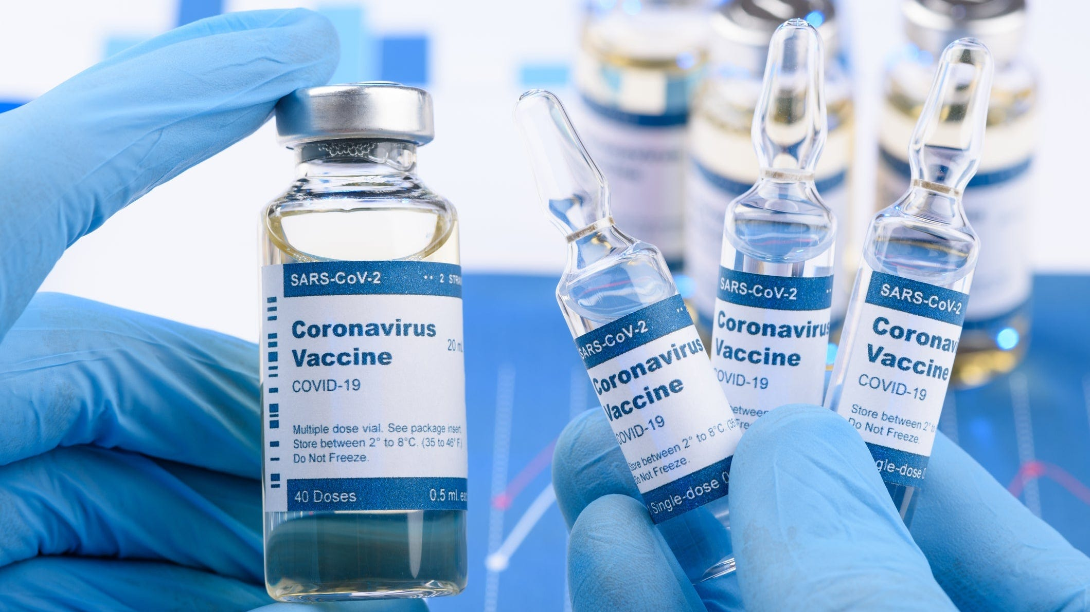

**Prebooking appointments through the MyGP App**

Please note that we now have limited appointments that are available to book the night before on the MyGP App. These appointments are released at 6.30pm Sunday-Thursday.

SMOKING CESSATION

Smoking can lead to strokes, cancer, heart and lung disease. We strongly advise quitting. The best way to stop is with a combination of medication and specialist support.

*You can try the NHS Quit Smoking app, or for more information visit:* [*www.nhs.uk/smokefree*](http://www.nhs.uk/smokefree)



*Bank Holiday Closures…*



**It is officially Spring!** Lighter nights and warmer days are slowly coming.

Hay fever season will soon be upon us. Airborne grass pollens are at their peak late March until mid-May, please make sure to stay protected.

***The lighter nights are approaching…***

Haslingden Healthcare is now participating in clinical trials.

Some patients may be contacted and receive a message alert about these clinical trials requesting you to join in.

If you are interested in the clinical trial then follow the instructions in the message you receive, please do not contact reception about this.

**No personal or medical information will be released without your consent.**



Clinical Trials

Prescriptions

Just a gentle reminder to patients that our prescription phone line is open from 9.00am-12.00pm.

Alternatively, you can order prescriptions through the NHS app, email or pop into reception.

**Stay up to date:**

Facebook – Haslingden Healthcare Ltd

Email – [mackenzie.reception@nhs.net](mailto:mackenzie.reception@nhs.net)

Number – 01706 335390

Would you like to join our PATIENT PARTICIPATION GROUP?

We are looking for enthusiastic, dedicated patients for their views on upcoming changes and to help shape the delivery of services. Some questions that could be raised are below…

* How long do I have to wait for a GP appointment?
* How can I access mental health services?
* I just want to check my blood test results, can I do this without speaking to a healthcare professional?
* Why do the receptionists need to know what my appointment is for?

For more information please contact reception:

01706 335590 or mackenzie.reception@nhs.net

*Finding An Agent That’s Right For You*